METRO TICKET BOOKING SYSTEM
3 Project Design Phase

3.1 ER Diagram
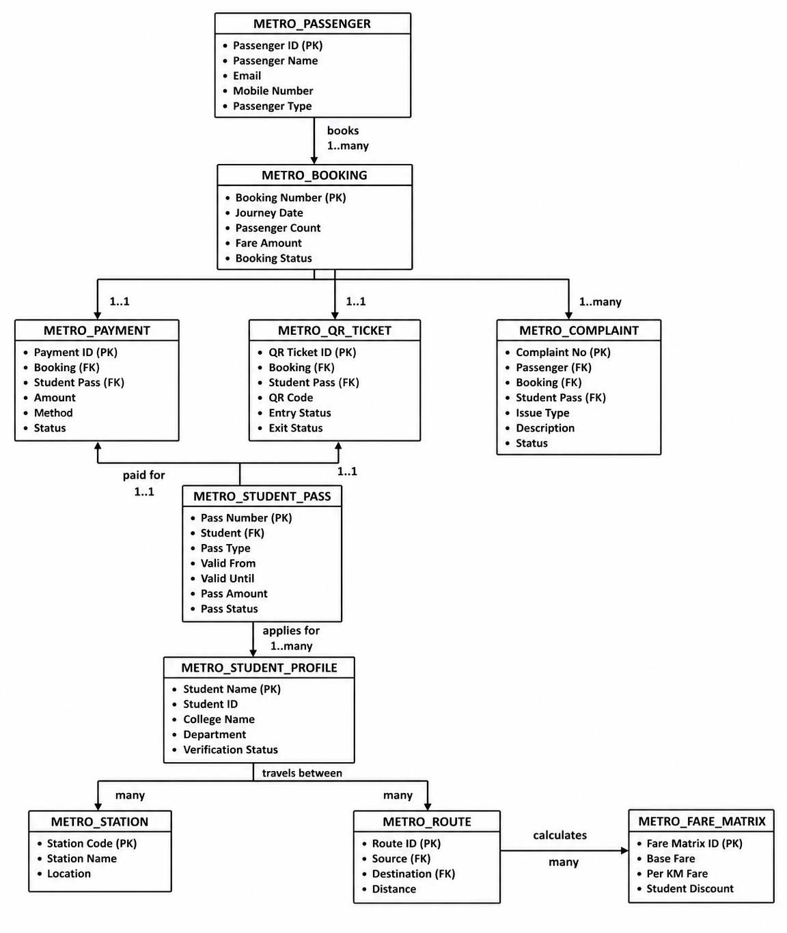

3.2 Data Model Table and Design

Entity | Description | Relationships
Metro Passenger | Stores passenger information | One Passenger → Many Bookings
Metro Student Profile | Stores student details | One Student → Many Passes
Metro Station | Stores station information | Referenced by Routes and Bookings
Metro Route | Stores route information | One Route → Many Bookings
Metro Fare Matrix | Stores fare data | Used by Booking and Pass
Metro Booking | Main booking table | Parent Entity
Metro Student Pass | Stores pass details | One Student → Many Passes
Metro Payment | Stores payment records | One Booking/Pass → One Payment
Metro QR Ticket | Stores QR tickets | One Booking/Pass → One QR Ticket
Metro Complaint | Stores complaints | One Passenger → Many Complaints

3.3 Functional Modules
- Ticket Booking
- Student Pass Management
- Payment Processing
- QR Ticket Generation
- Complaint Management
- Dashboard & Reporting

3.4 Database Design

Metro Passenger Table :
Field Name | Purpose
Passenger Name | Stores passenger name
Email | Stores passenger email address
Mobile Number | Stores passenger contact number
Passenger Type | Identifies passenger category
Active | Shows whether passenger is active
User | Links passenger with ServiceNow user record

Metro Student Profile Table:
Field Name | Purpose
Student Name | Stores student name
User | Links student with ServiceNow user
College Name | Stores college name
Student ID Number | Stores student ID
Department | Stores department
Year | Stores academic year
Verification Status | Tracks approval status
Verified By | Stores verifier/admin
Verified Date | Stores verification date

Metro Booking Table :
Field Name | Purpose
Booking Number | Unique booking ID
Passenger | Links booking to passenger
Source Station | Starting station
Destination Station | Ending station
Journey Date | Travel date
Passenger Count | Number of passengers
Fare Amount | Calculated fare
Payment Status | Payment tracking
Booking Status | Booking state
Number | Auto-generated booking number

Metro Student Pass Table :
Field Name | Purpose
Pass Number | Unique student pass ID
Student | Links pass to student profile
Pass Type | Weekly or monthly pass
Source Station | Starting station
Destination Station | Ending station
Valid From | Pass start date
Valid Until | Pass expiry date
Pass Amount | Calculated pass amount
Payment Status | Tracks payment
Pass Status | Active, expired, draft
QR Ticket | Links generated QR ticket
Number | Auto-generated pass number

Metro Payment Table :
Field Name | Purpose
Payment ID | Unique payment identifier
Booking | Links payment to booking
Student Pass | Links payment to student pass
Payment Method | UPI, Card, Net Banking
Amount | Payment amount
Transaction Status | Success, failed, pending
Transaction Reference | Payment reference ID
Payment Time | Payment completion time

Metro QR Ticket Table :
Field Name | Purpose
QR Ticket ID | Unique QR ticket ID
Booking | Links QR to booking
Student Pass | Links QR to student pass
QR Code Value | Stores QR code data
Valid From | QR valid start date
Valid Until | QR expiry date
Entry Status | Entry scan status
Exit Status | Exit scan status
Ticket Status | Active, used, expired

Metro Complaint Table:
Field Name | Purpose
Complaint Number | Unique complaint ID
Passenger | Links complaint to passenger
Booking | Links complaint to booking
Student Pass | Links complaint to pass
Issue Type | Complaint category
Description | Complaint details
Status | New, in progress, resolved
Assigned To | Assigned admin/support user
Number | Auto-generated complaint number

3.5 Design Considerations
- User-friendly Interface
- Easy Navigation
- Modular Architecture
- Maintainability
- Scalability
- Role-based Security
- Workflow Automation
- Real-time Analytics

